FINAL EXAMINATION
TIME ALLOWED: 90’
Subject: Linear Algebra. No books allowed.

1/ Determine all real value(s) m such that 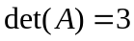, where
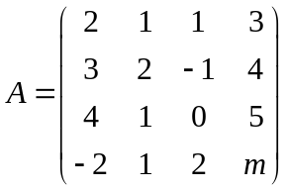.
2/ Solve the linear system 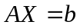, where 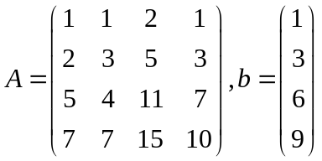.

3/ Determine the dimension as well as a basis for the space spaned by three vectors
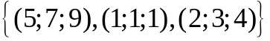

4/ Given an inner product in 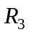 as follow:
.
Find the length of the vector 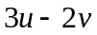, where 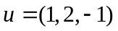 and 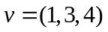.

5/ Let 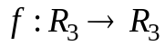 be a linear transformation. Given that . Find 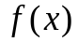.

6/ Let be a linear transformation. Compute 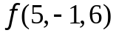 , given that
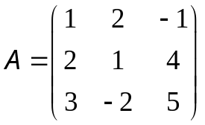 is the matrix of 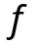with respect to the basic 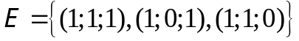.
7/ Diagonalize (if possible) the matrix 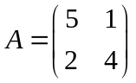.

8/ Make a change of variables that transforms the quadratic form
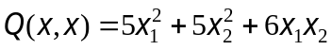 into the canonic form (using the orthogonal diagonalization method).

-----------------------  -----------------------

